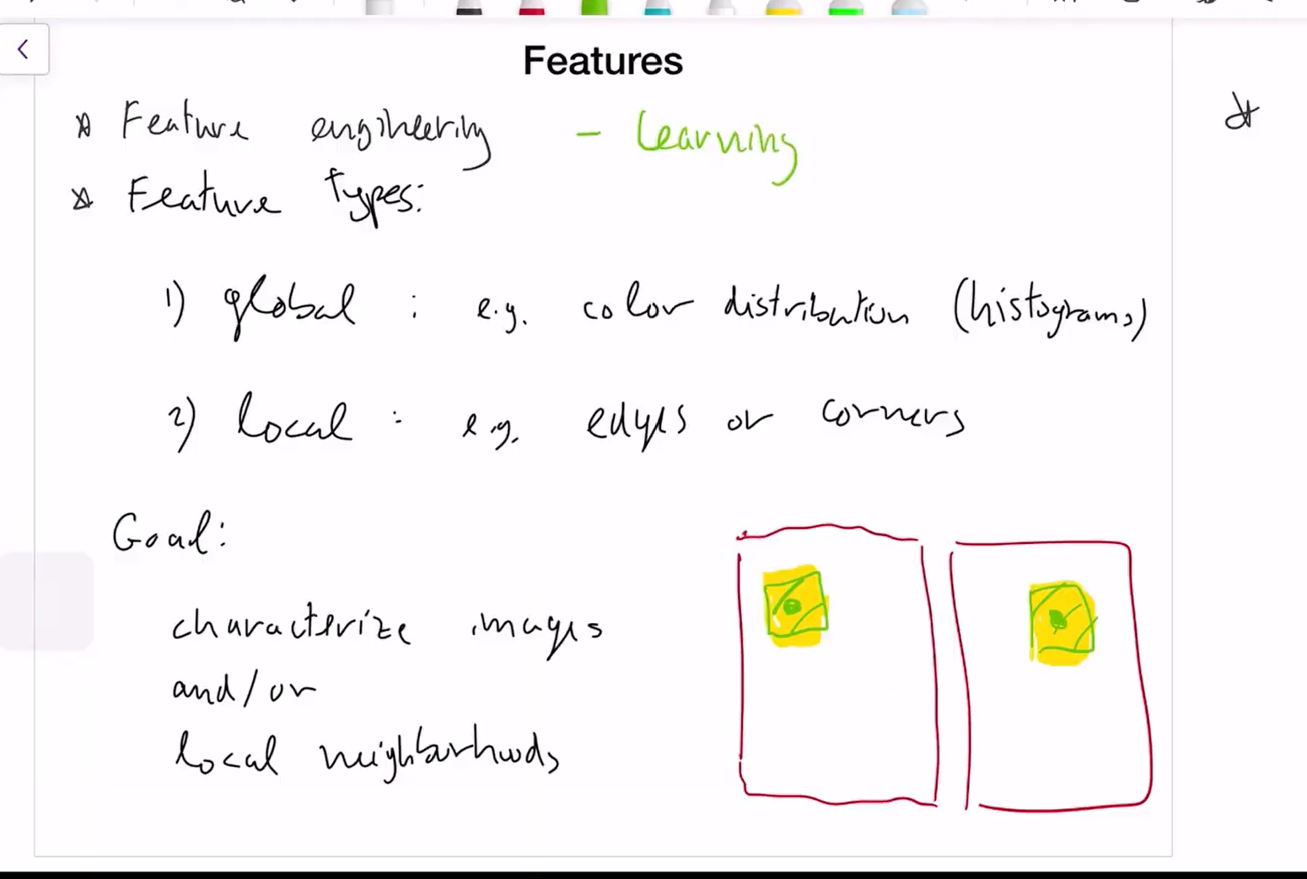

Feature engineering - we give the features to look at/extract

Feature Learning – The n/w learns by itself.

Global – trying to match up similar images by characterizing the whole image

Local - trying to find details in an image

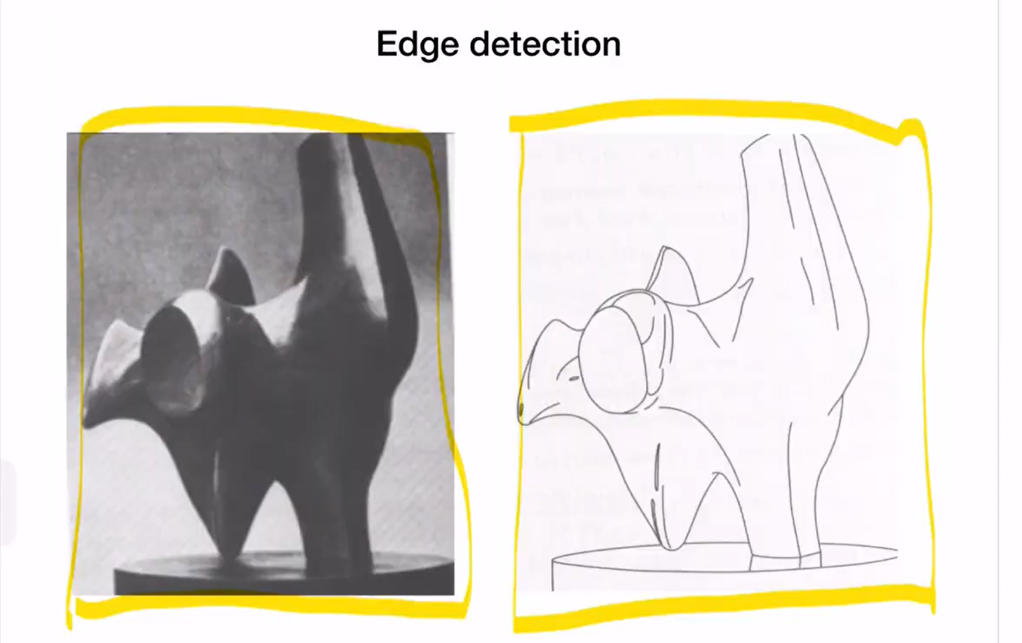

Edge detection – captures the essence of image – amount of information may be less but can represent the knowlegde of the image compactly. Compression of original image would be difficult as it has more information but edge detection , we can do high compression

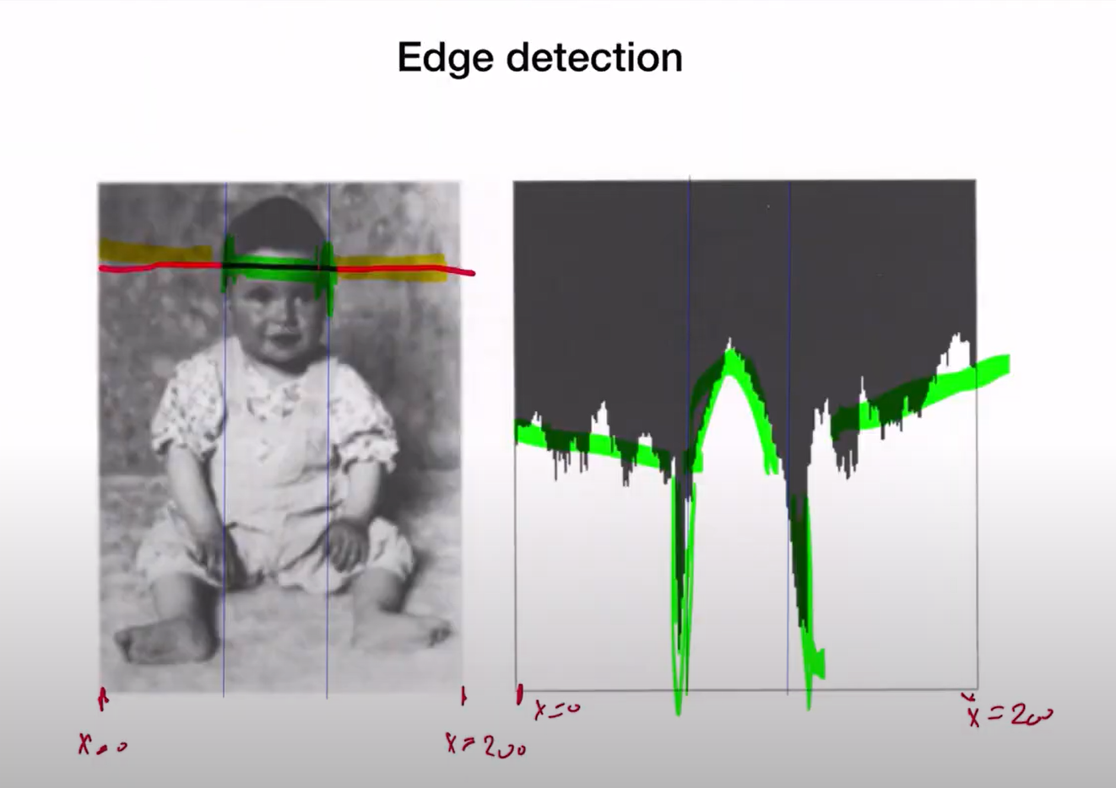

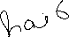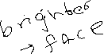

Edge detection in the image, consder the cross section(the red line), From left to right, the background is greyish, then comes the hariline(black), then skin of forehead (bright), again harline(black ) and then background(grey)

On the right, we see the corresponding intensity variations. We see that the background/greyish part have medium intensity while the black harilines portions have low intensity and the forehead porttion has high intensity due to skin color.

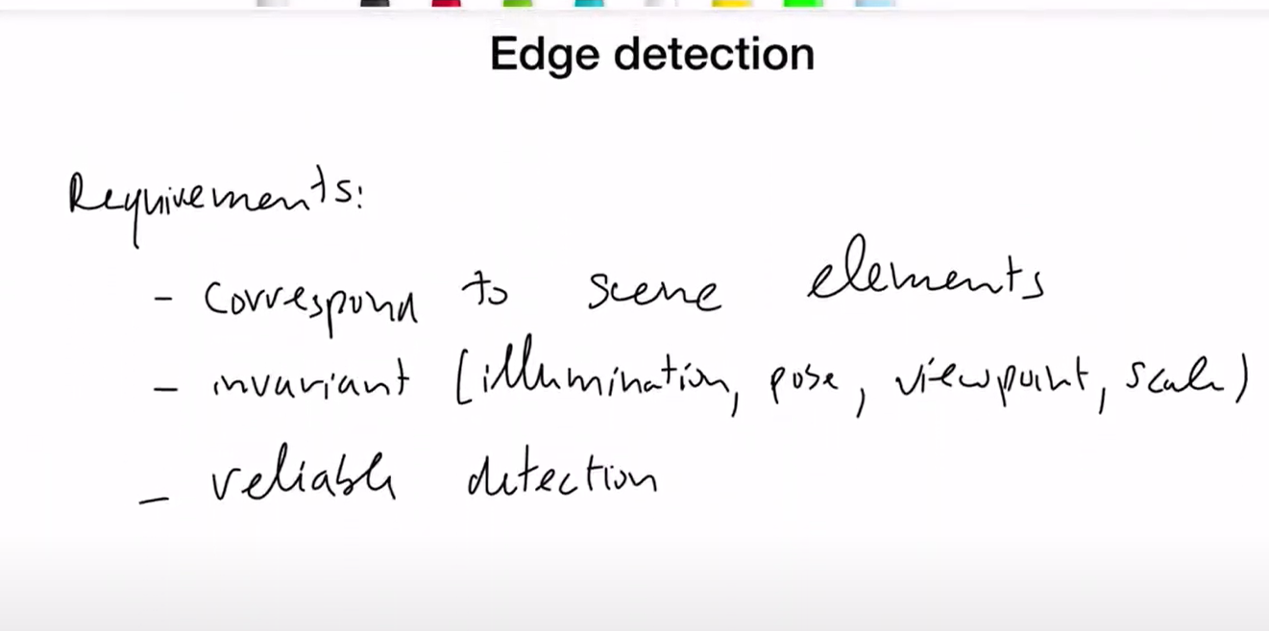

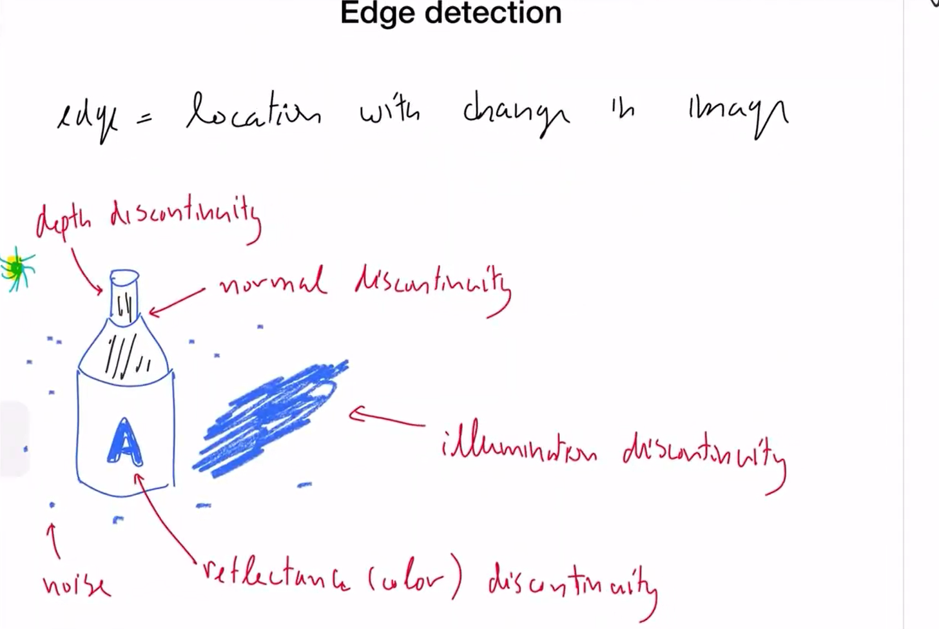

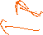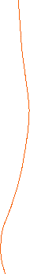

Depth discontintuiy – there is a diff in depth of background and the bottle

Illuminaition – shadow – subjec tto change based on the lighting

Reflectance/color – change in color , no change in depth

Normal - no depth or color change, it is the change in the normal to the surface from that point which changes the illumination

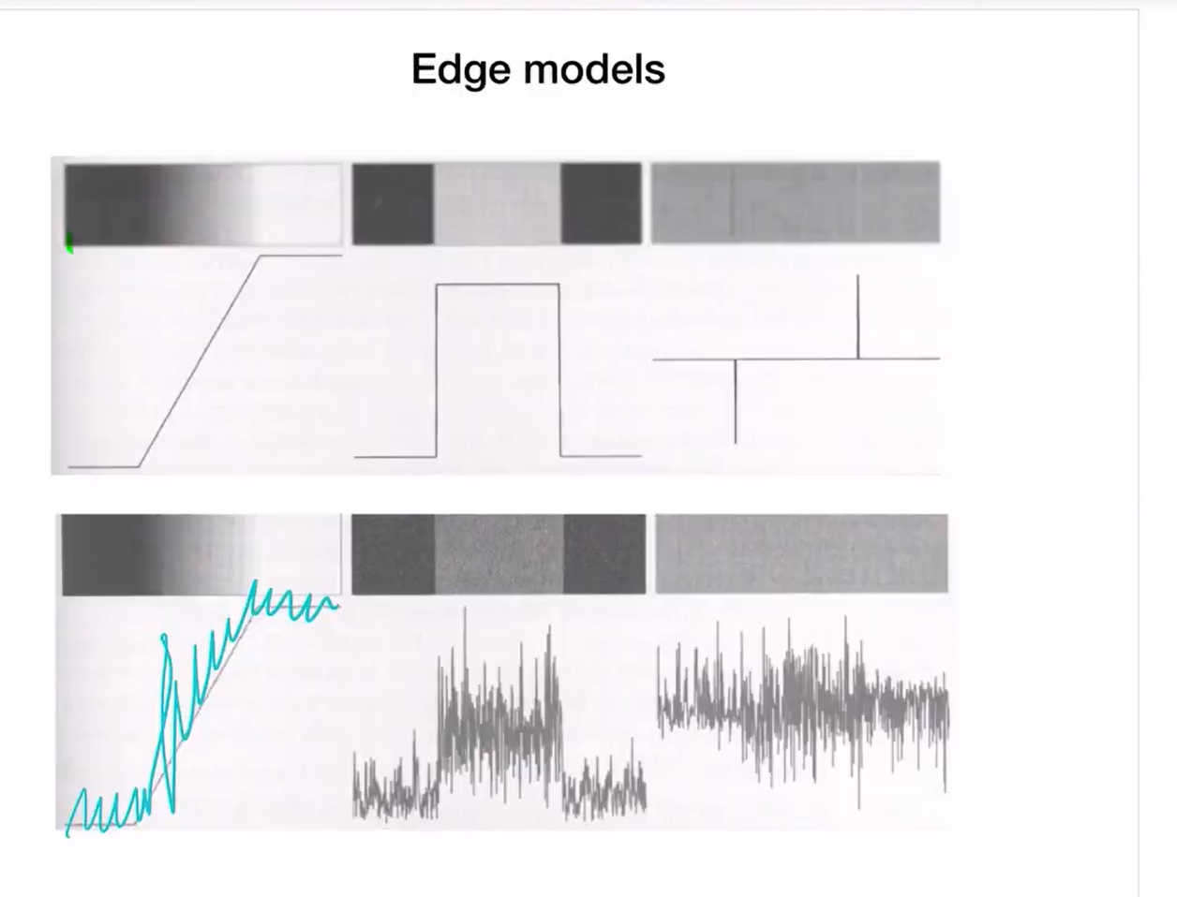

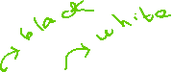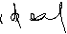

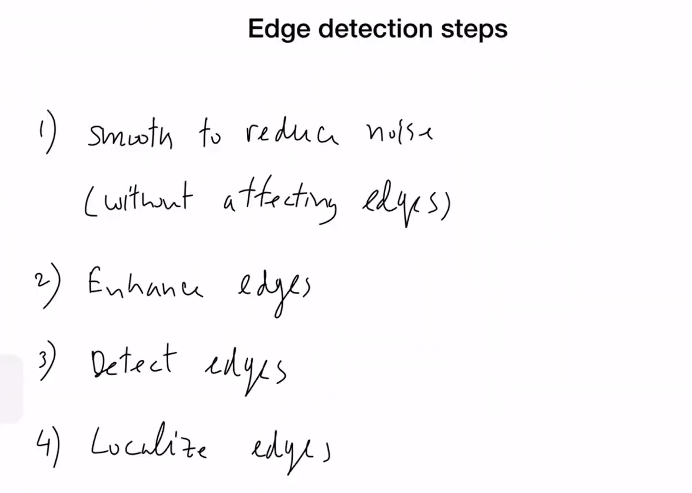

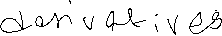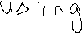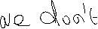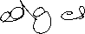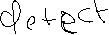

Localize edges- detect the edges accurately for some sensisitve purpose

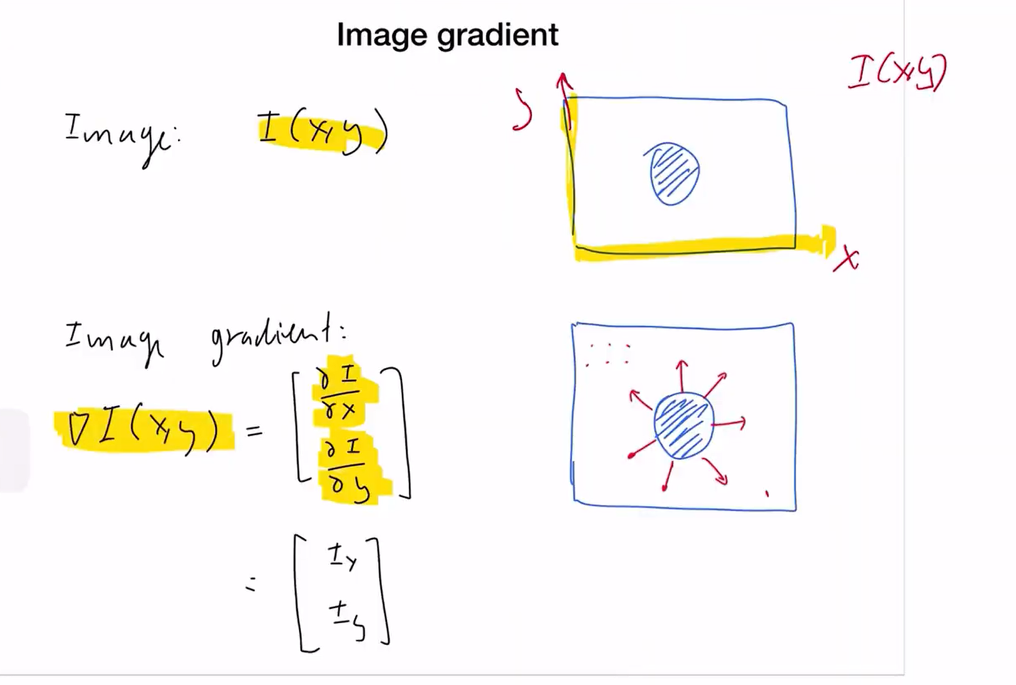

Consider an image with a black circle in the center. The areas other than the circle have no change in intensity , so there is no change in the x and y direction values and hence the derivatives would be xero resulting in zero vectors. Also at the center, inside the circle, it is all black and the derviatives are zero.

The only points where there are changes is along the contour of the circle. So, the derviatives/gradients results in the vector that points in the maximal direction.

the "maximal" direction is effectively the direction you would move to experience the largest change in color intensity, which is along the radius of the circle, pointing outward from the center.

gradient direction - always indicates the path to greater intensity.

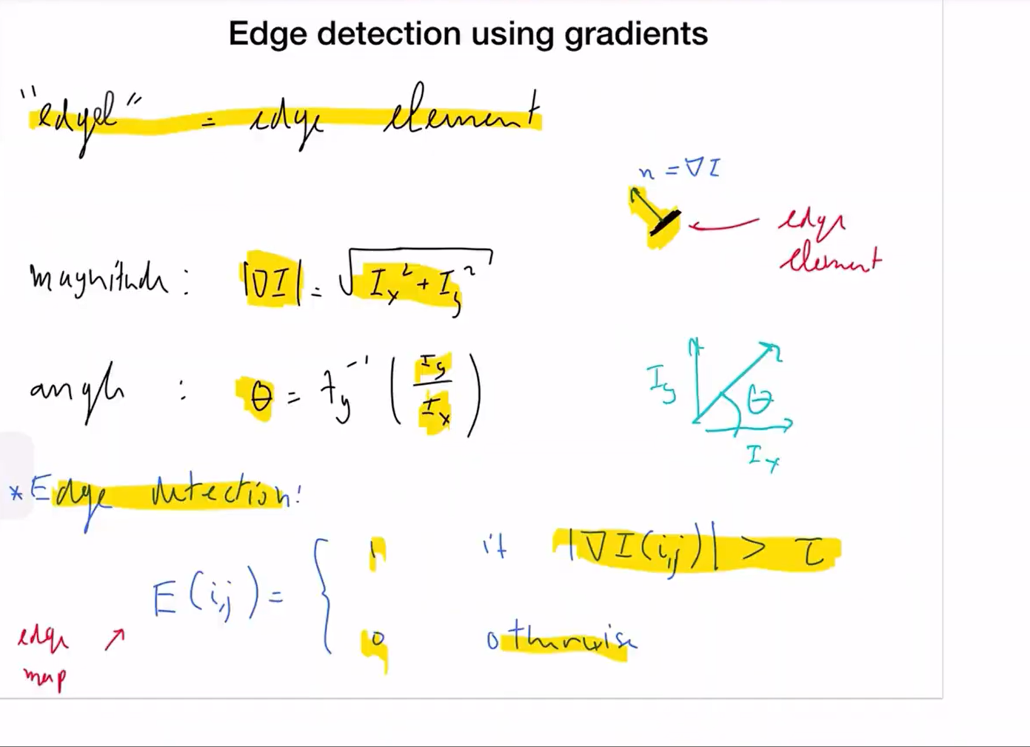

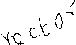

Any vector in general has 2 components which represent the unit/basis vectors at the origin of the system

The gradient vector has 2 components , Ix and Iy 🡪using that we get the magnitude and angle from tan theta (tan inverse).

The way we detect is to actually compute the gradient at every point of the image and then set some threshodl value tau and then decide uponon its comdition

Threshold --🡪high 🡪 very few edges. Low🡪more edges.

We have find a balancing value of threshold (hyper parameter)

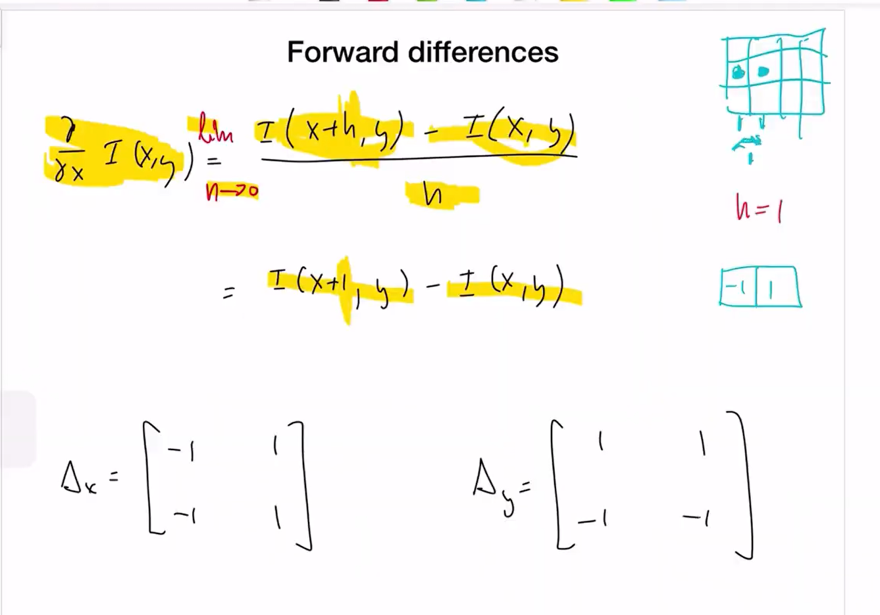

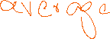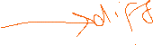

Calculation of gradient/derivative - --

What is h? 🡪 it is the distance between point 1 and 2 between which we are calculatng the differences.

The minimum value is 1 pixel (when we compare the neighboring pixel – idelally done this way fot gradient)🡪so, it is always 1.

As we are subtracting from the future(next pixel -> x+1) from x, we call it forward difference.

The direction does not really matter as we only need the diff and the gradient .

The last 2 matrices above shows the convolv fiter matrix that will be used with the image. It is absolutely fine to change the direction of dofference as

[1 -1

1. -1]

We are actually calculating the diff in one direction and the avaerage in the other direction

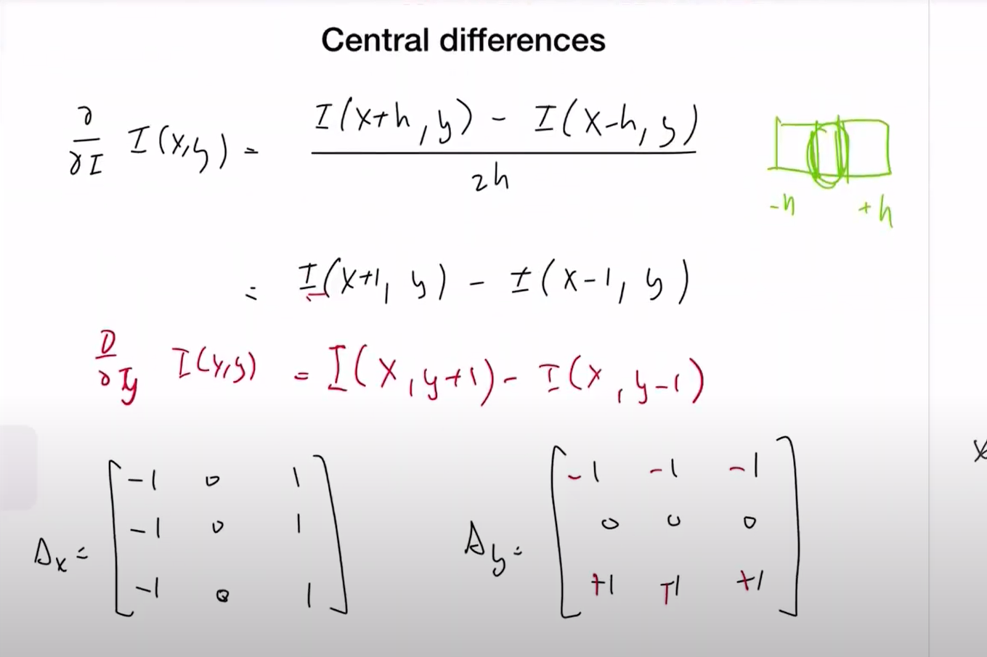



3x3 because it is central dofference

The value of center is the diff b/w the left and righjt neighbour. We can divide by 2 as h=1, but it doesn’t erally matter if we divide or multiply the value with anything as it would just scale the value and there is no impact

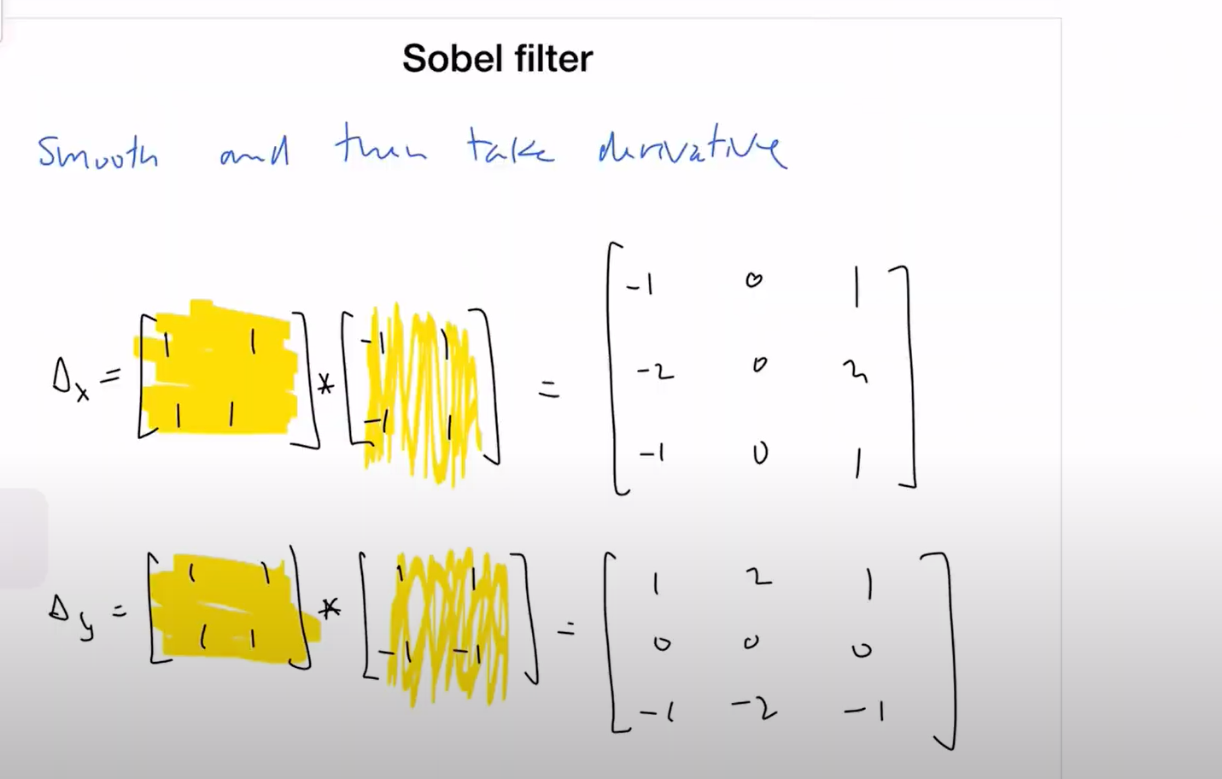

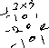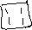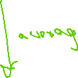

The first matrix is used to smooth the image with average values (1111) and the second matrix is the gradient derivative. We convolve these two filters and then apply the resulting filter to thr image to perform the smoothing and filter extractiion derivative filter.

This is not matrix multiplication, it is convolution with zero padding

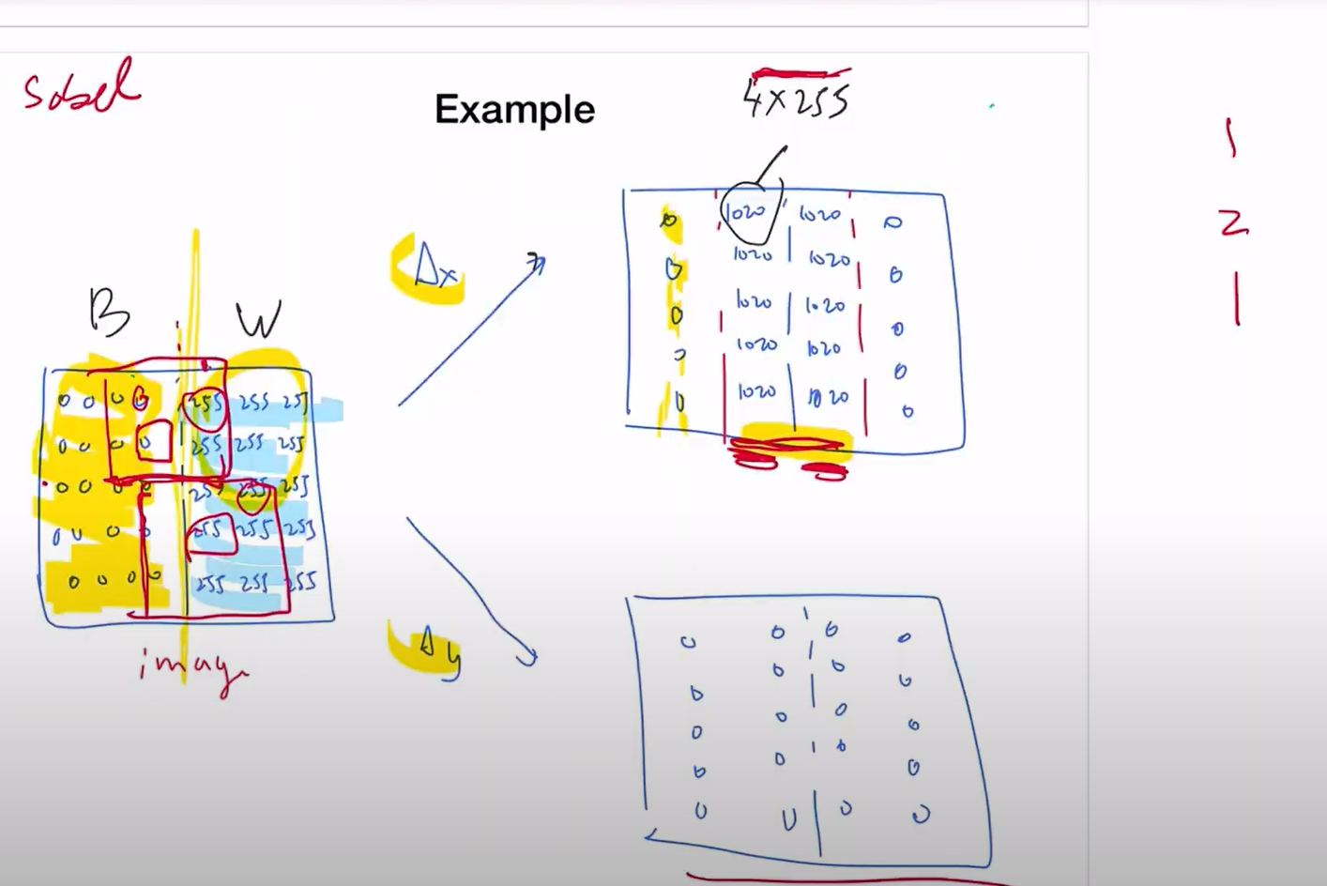



The thinner line of diff in the image shows a thicker difference at the edge in x derivative.

There is no change in y direction, so derivative is zero

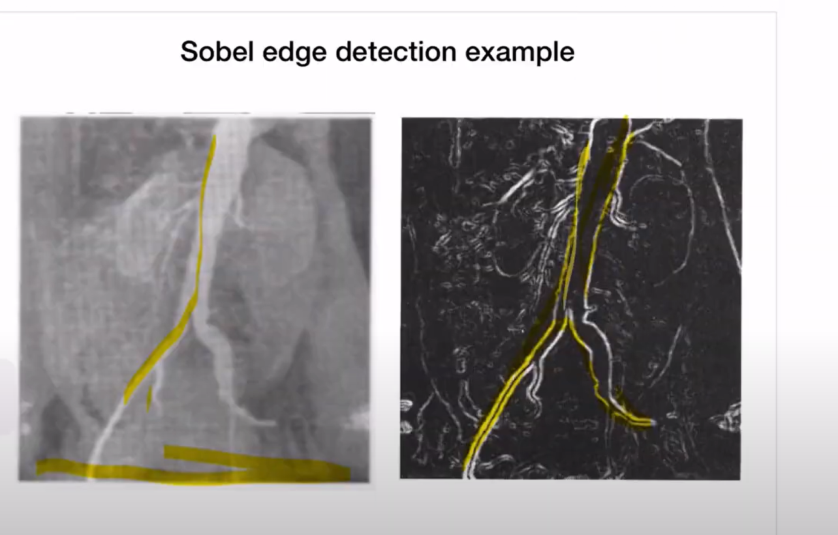

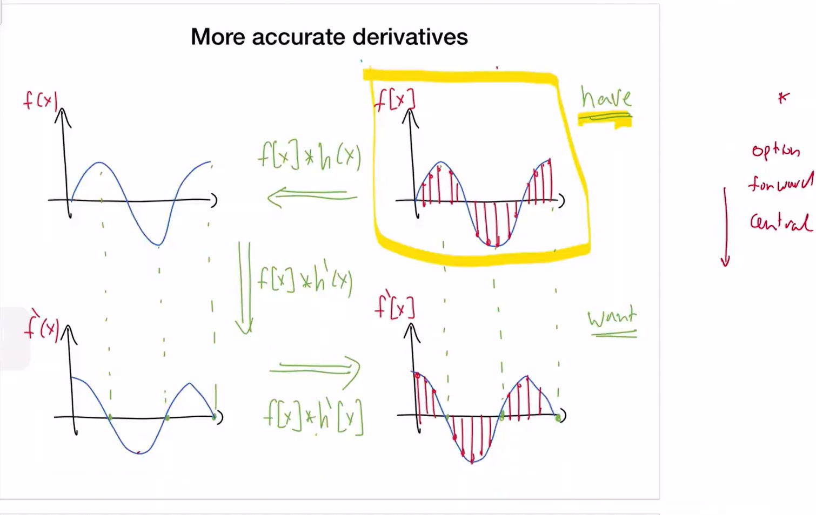

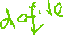

The image is a discrete value and it has only sample values (the redlines f[x]) and hence we cannot take the derivative and apply the limit 🡪h, but we can convert the discrete value to continuous value function f(x) by interpolating the sample values ()and then take derivative of the value x. We then convert it back to the discrete value rsulting in accurate derivative values.

H(x) is the interpolator

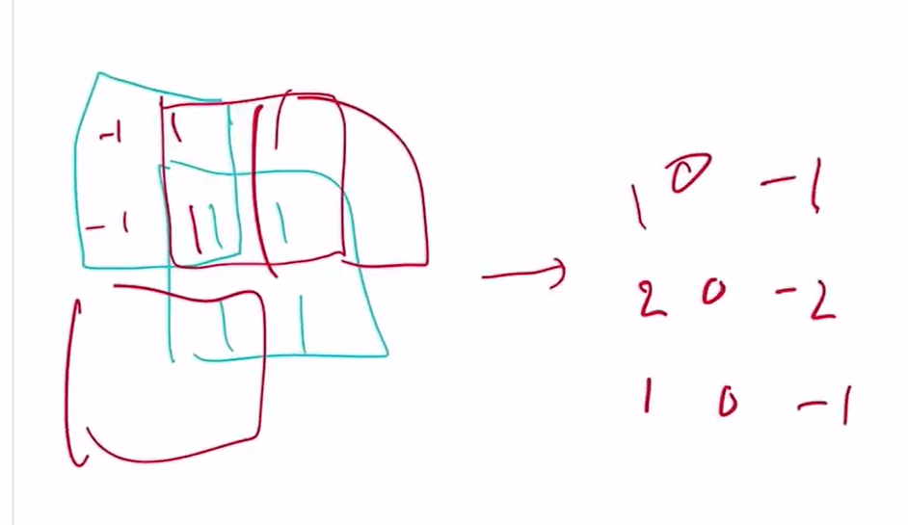

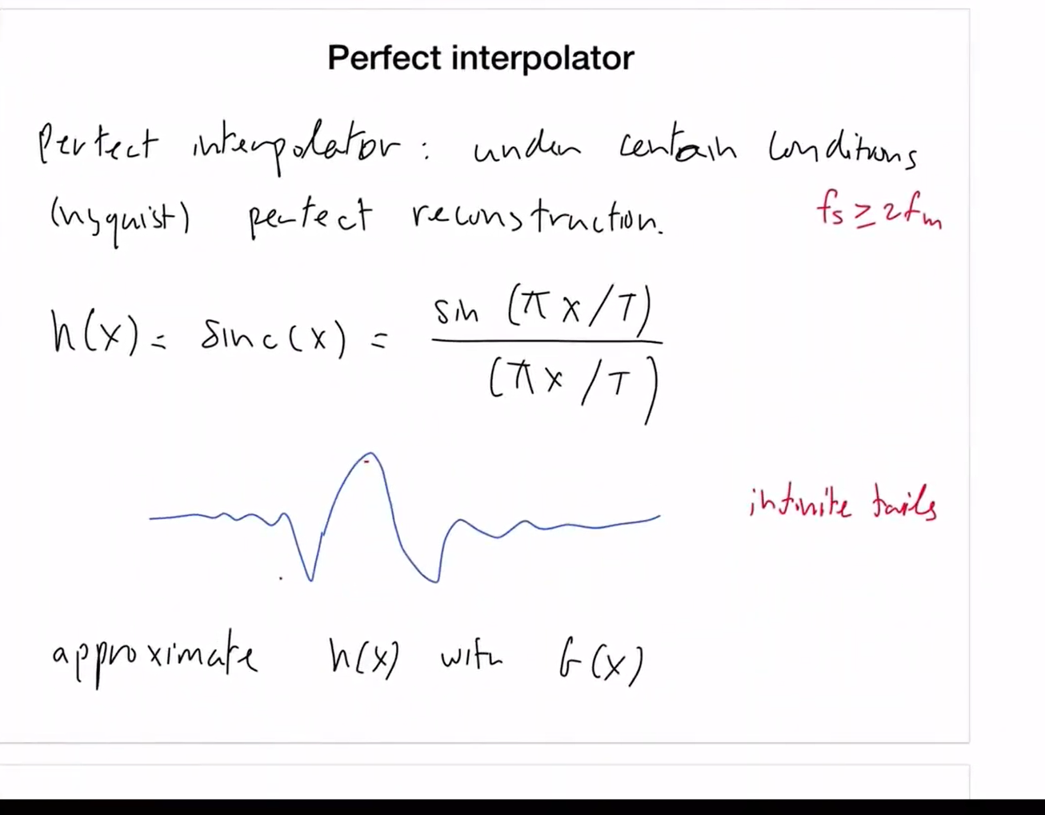



Perfect interpo;ator – acccurately reconstructing the signal from samples

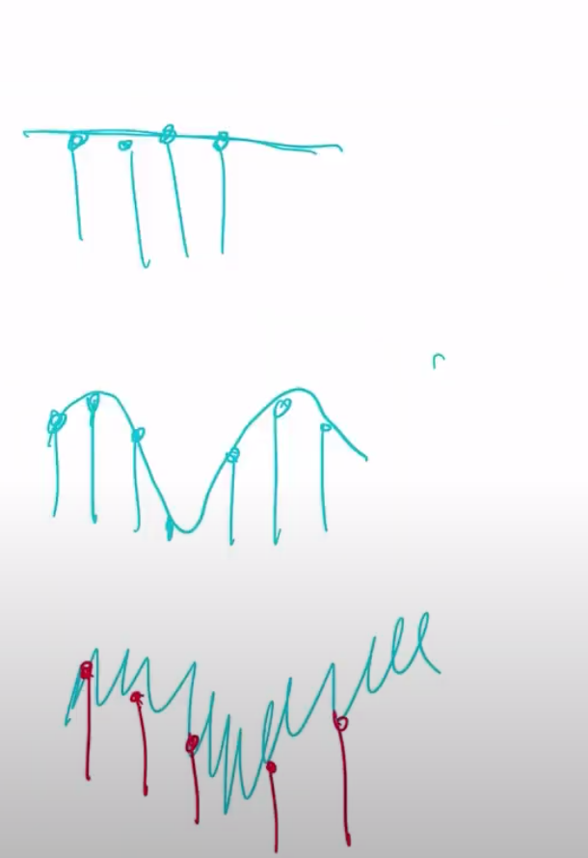

Reconstructing the first 2 signals may be easier but it is hard to reconstruct thrid variation with sampling

So, do take mor esamples when there are more variations --dense sampling

Fs>2fm is the sampling function.fm is the maximum signal frequency .

We should take twice the maximum signal frequency as sample frequency

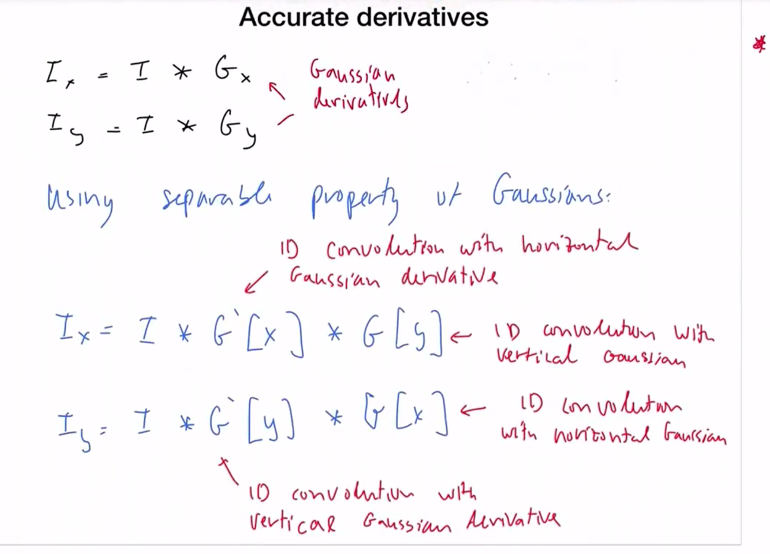

1D Gaussian x---exp(-(x**2)/(2*sigma**2))

1D Gaussian derivative - -(x/sigma**2) * np.exp(-(x**2)/(2*sigma**2))

Separable property of Gaussian – spliting up 2d to two 1d

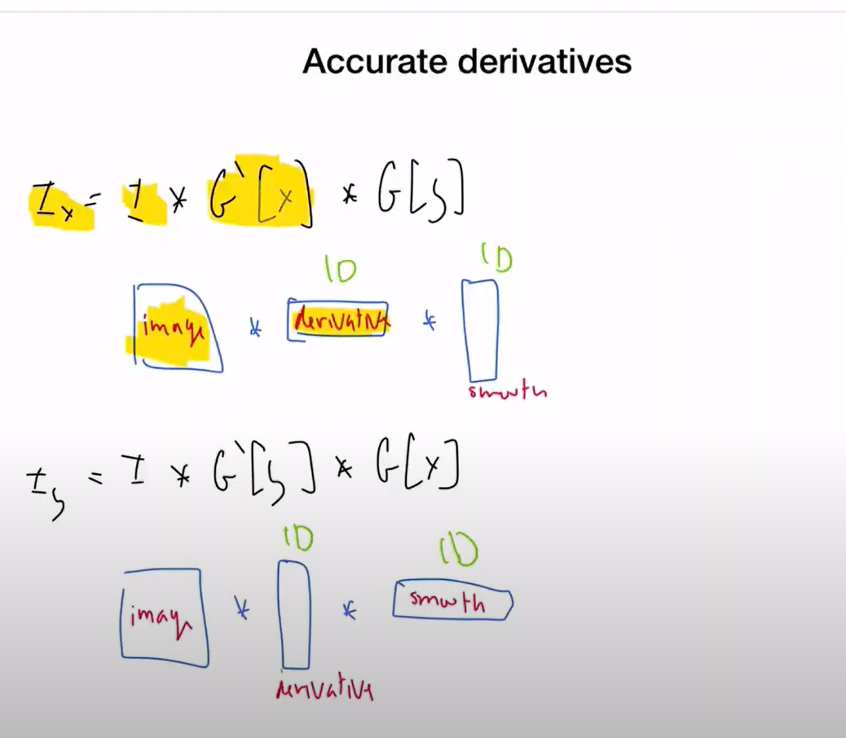

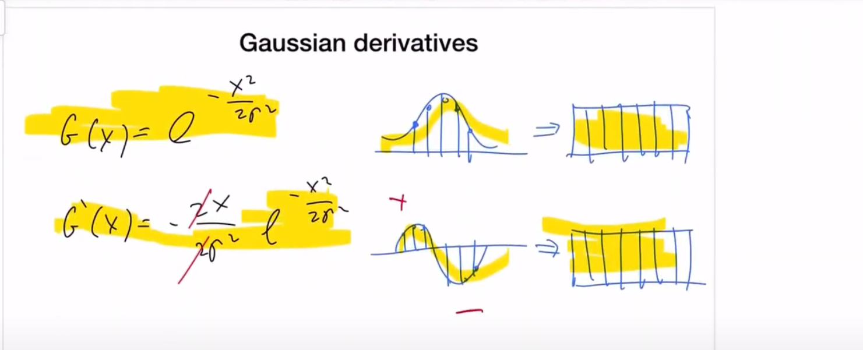

Probably an egde where there is smooth transition fon blavk to white

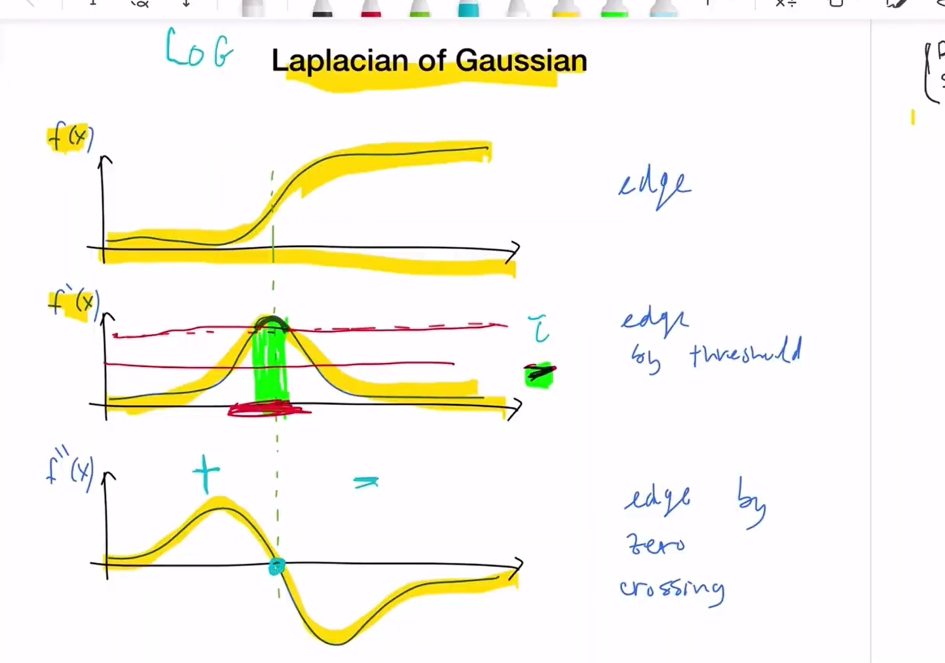

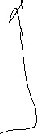

Advantage of taking second derivative- - easily identified by +/- signs

In first derivative, when the value is greater than th threshold we consider those part to be edge. It usually is thicker than the actual edge because the dervivative is sufficiently meeting threshold for a larger region. The value chosen for threshold decides if the edge is thicker or thinner

LAPLACIAN 🡪means second derivative

GAUSSIAN – for smoothing

Derivatives are sensitive to noise and hence has to be smoothened

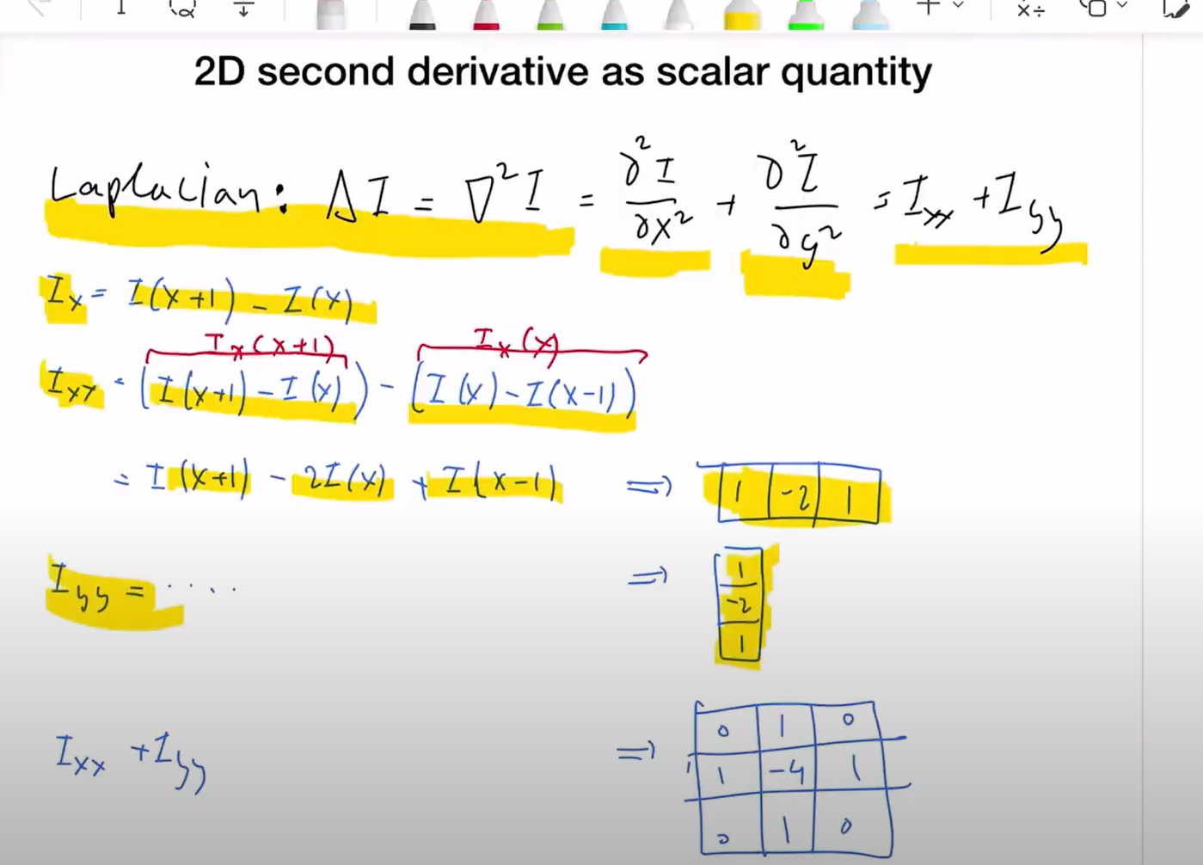



What is second derivative = measures the change in the first derivative as XXincreases by 1:

Change in first derivatives

I_xx = I_x(x+1) – I_x(x)

I_x(x) = diff b/w neighbours = I(x) – I(x-1)

I_x(x+1) = I(x+1) – I(x)

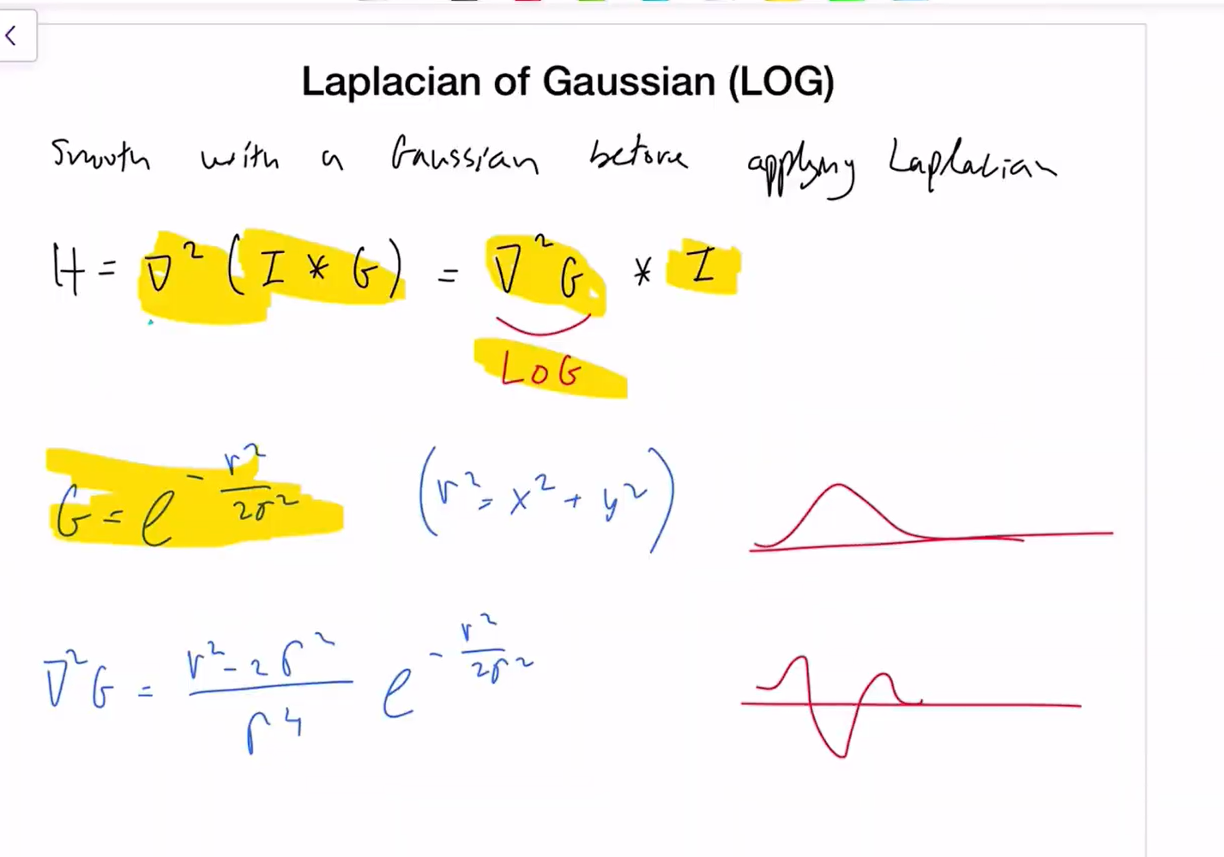

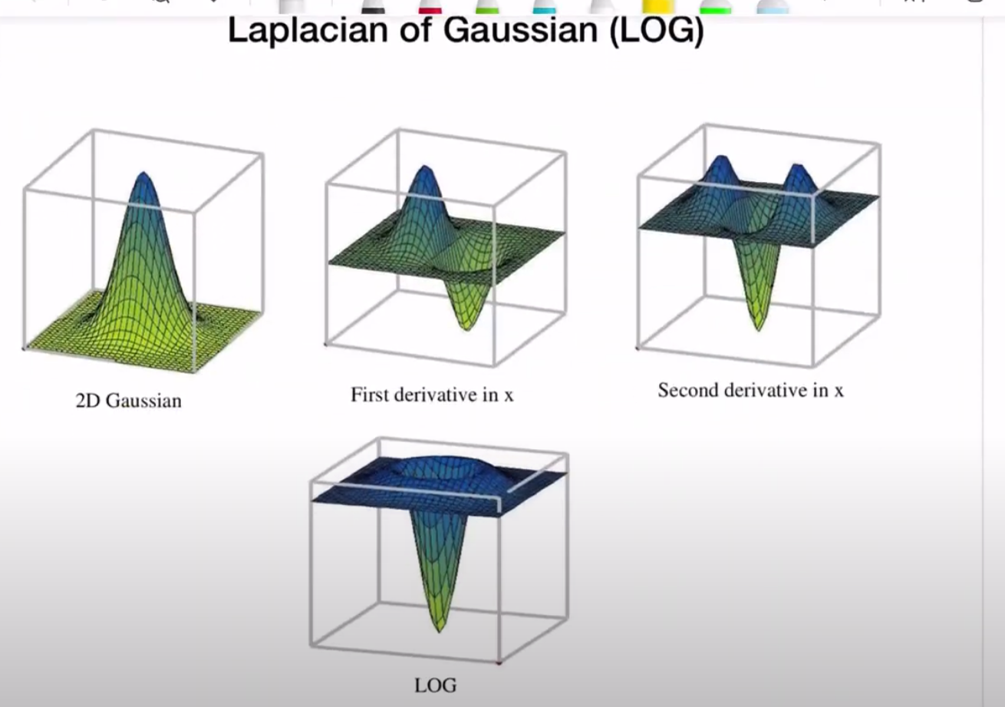

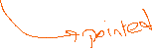

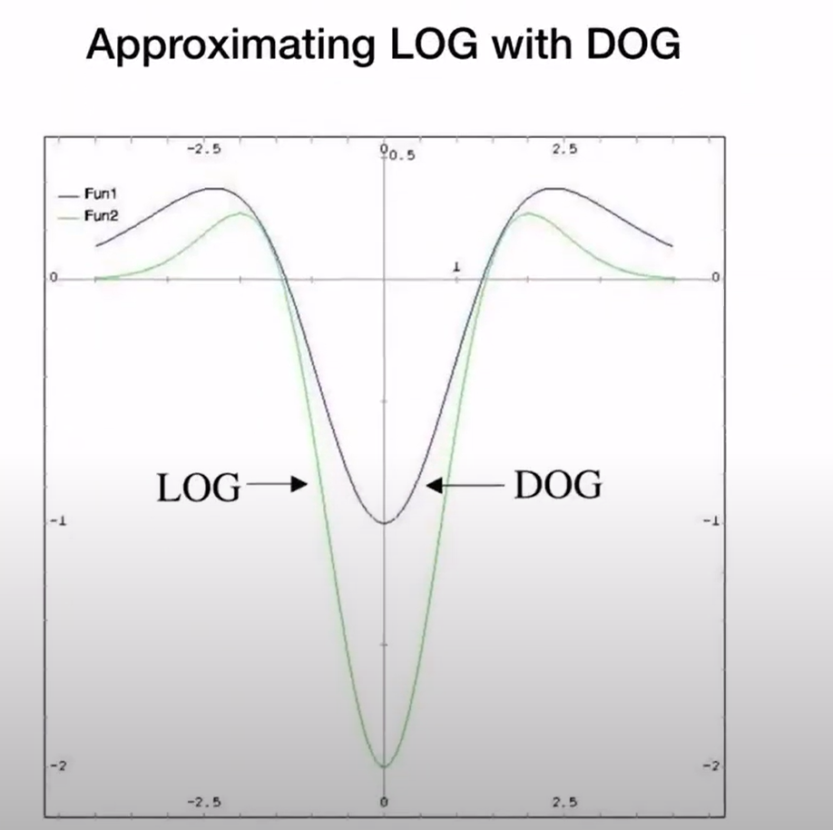

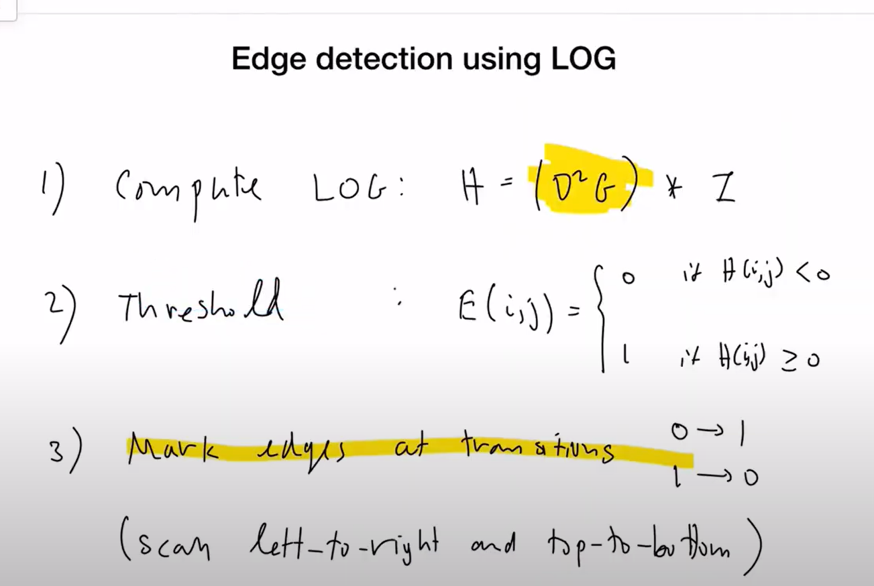

Mark all the negative values as o and positive values as 1 for easy seggregation

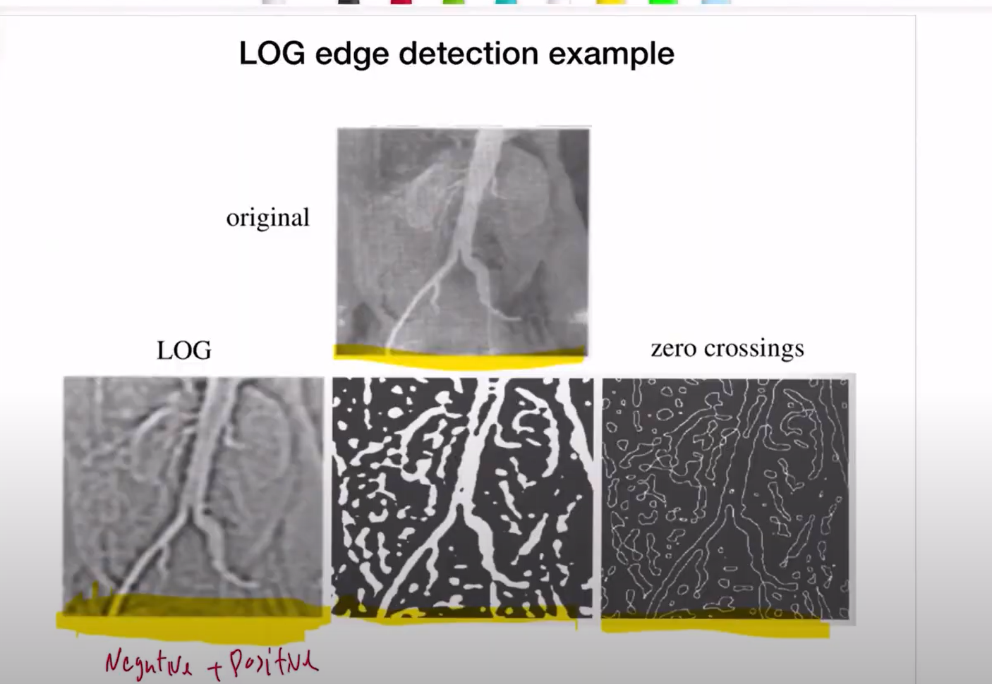

Left to right:

1. Normalized +ve and negative valued image
2. Binary image - +/1 white and -/0 black
3. Zero crossings

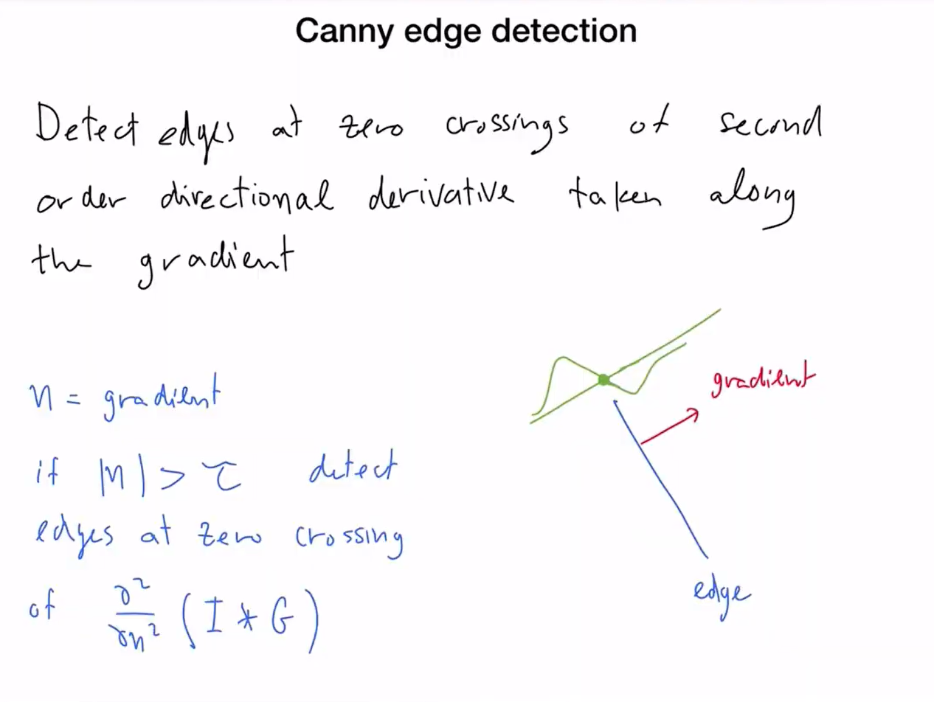

Other previously detected detection uses the gradients but this one used directional derivative

Gradient – perpendicular to the edge

Only when the gradient is big enough, we detect edges/take derivatives along the gradient

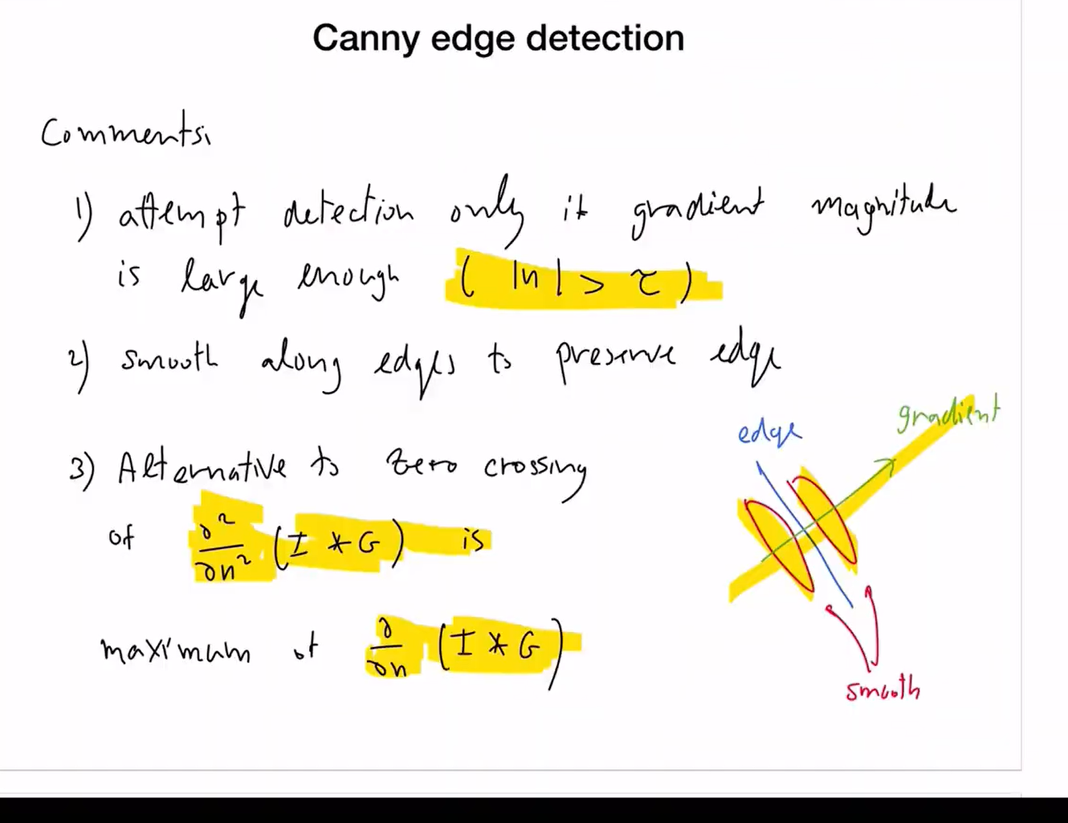smoothing is done along the edges (perpendicular to the gradient)

Calculating second derivative is expensive🡪so we take the maximum value from first derivative and use it as second derivative

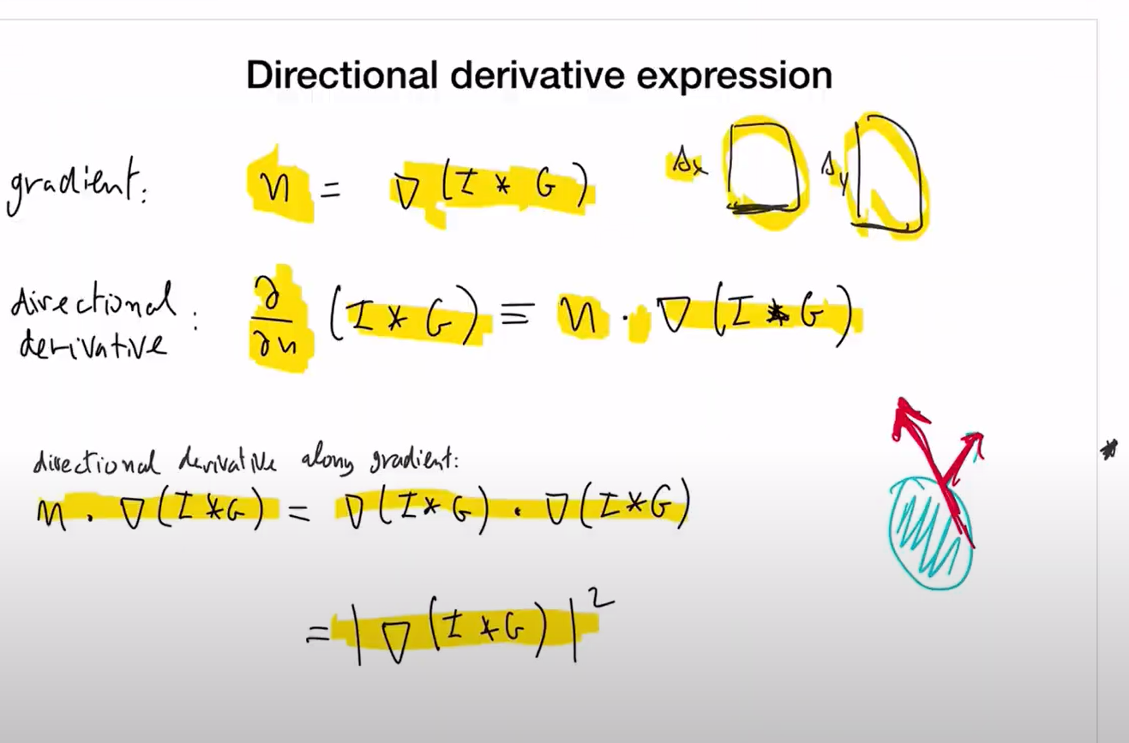

For Gradient, we take the first derivative of thesmoothened image (I*G) 🡪which means we take the image matrix and convolve it with delta x and delta y

What is directional derivative 🡪 dot product of the gradient normal to the edge and desired direction of smoothening --🡪projecting gradient onto given/desired direction

In Canny edge detection, the direction of gradient is the direction in which we are interested to take derivative--🡪 is the direction of gradient itself.

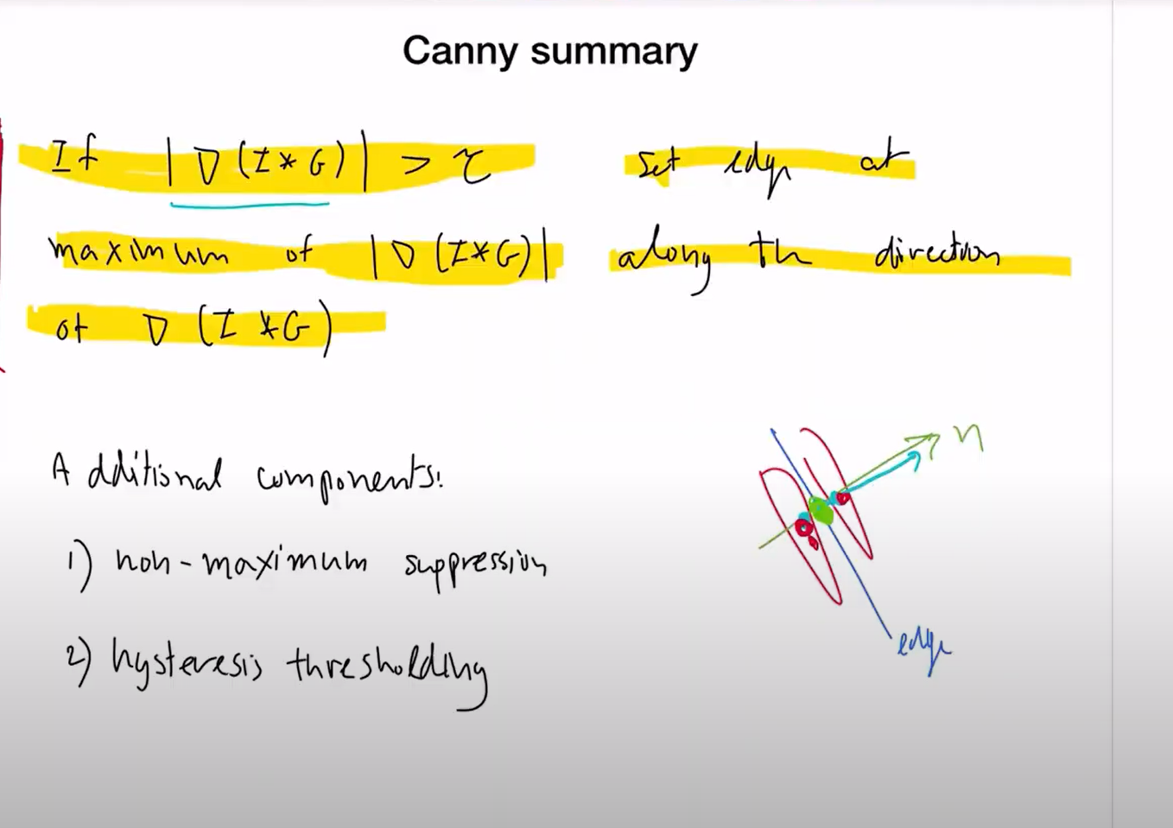

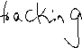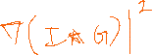

The statement meaning in above image - When we convolve , we get a thicker edge value at the center, however, we should look for the max value along the direction of the gradient so that we end picking the one at the edge accurately.

There will be many gradient values greater than threshold, we should choose the one that is maximum in the direction of the gradient

It doesn’t matter if we take max of the gradient or the square of the gradient, it’s the same max value.

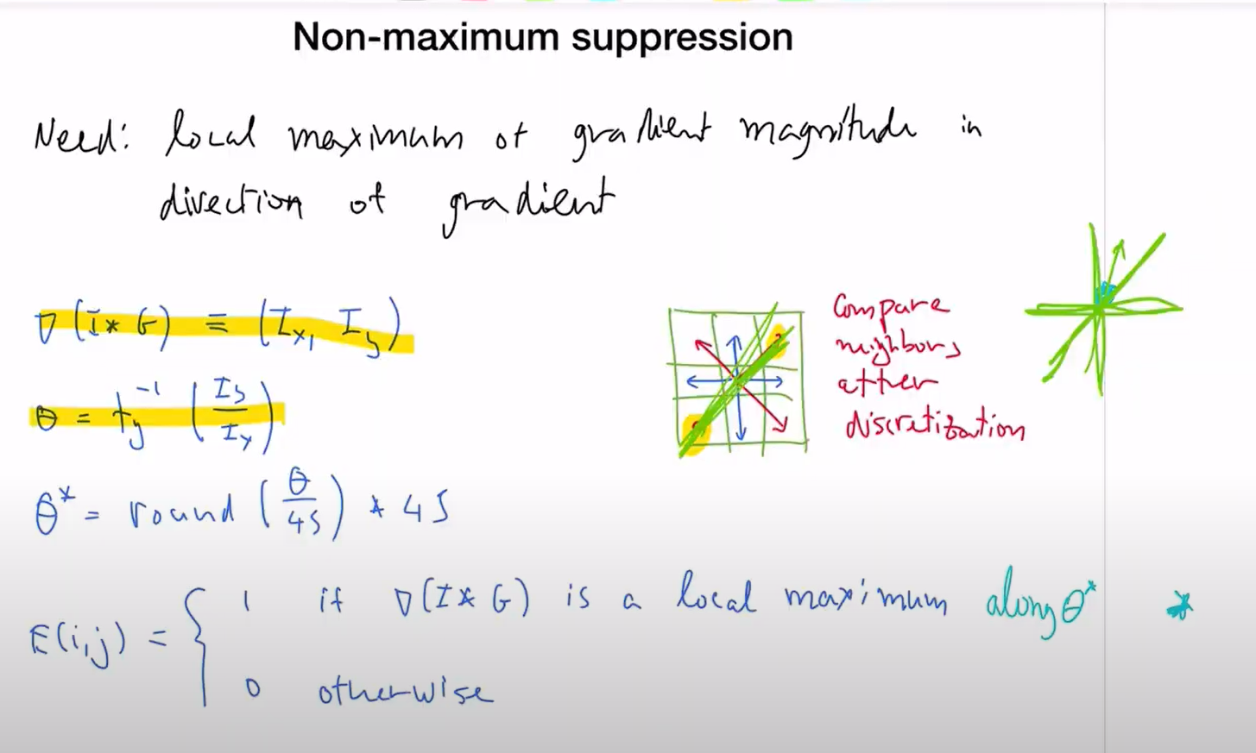

We look for opposite neighbors along the direction of gradient

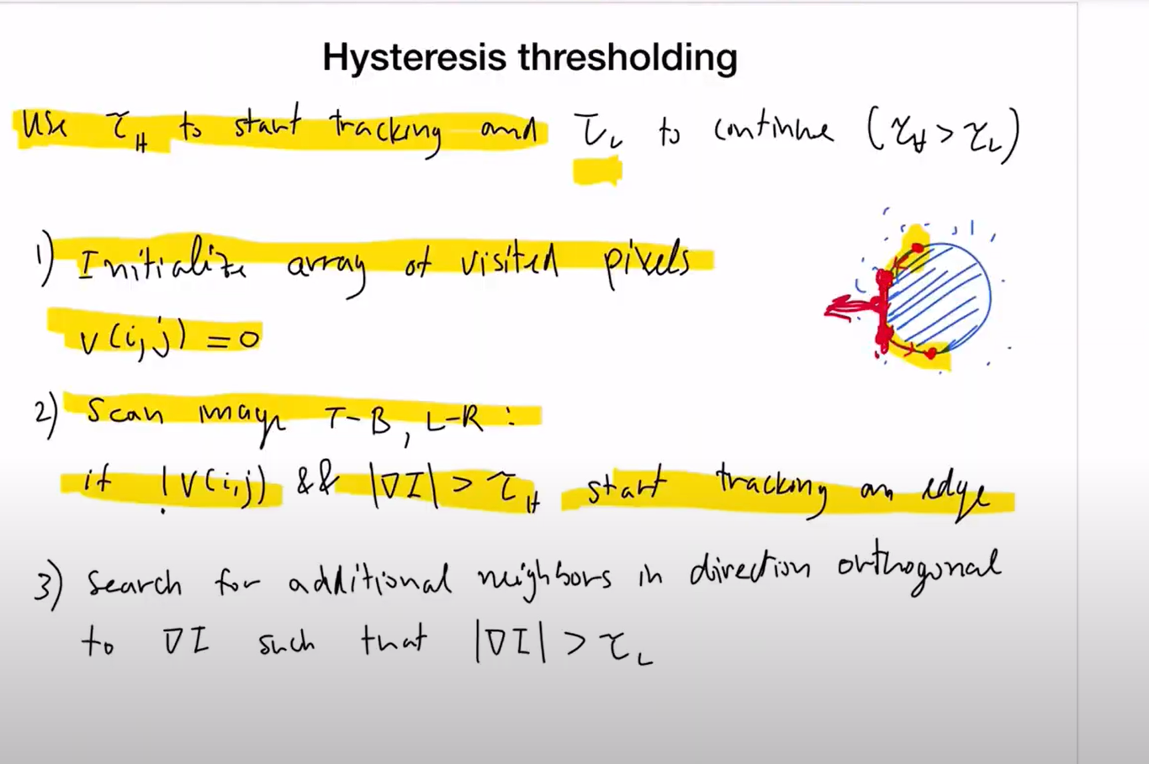

Look at the neighbours in the direction orthogonal to the gradient.(which means the direction of edge)

Use higher threshold to start with theedge, then later use lower threshold to find the local maximum and continue to track the edge

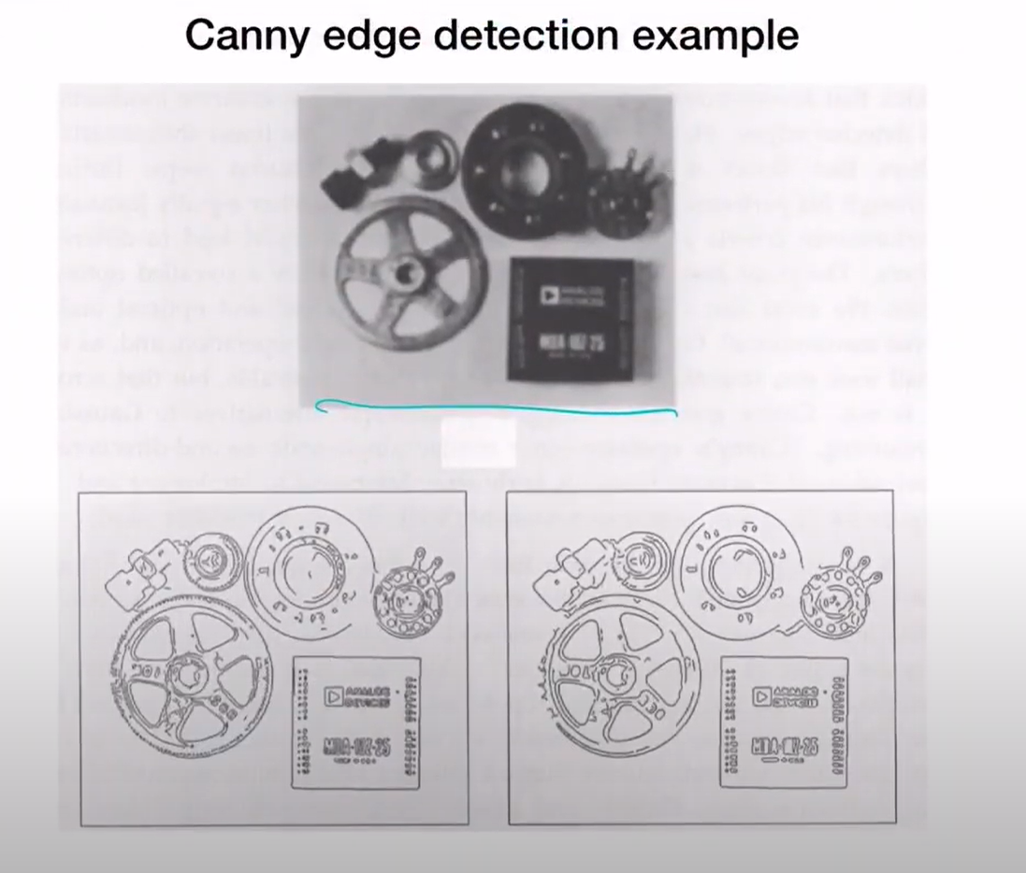

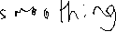

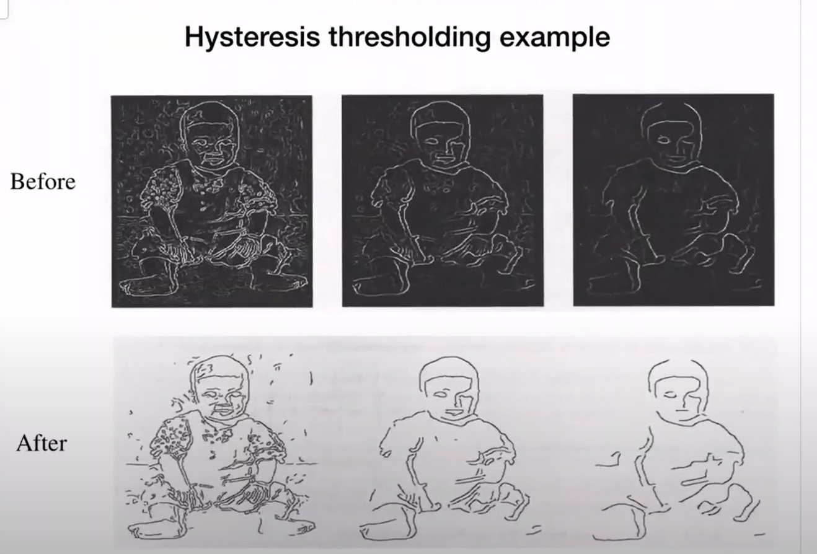

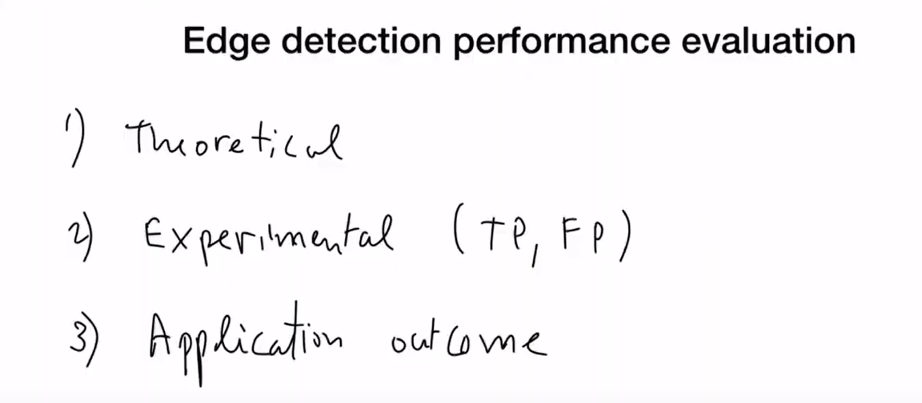

The above was not explained

